**Salvaviajes Website Features and Potentials**

# Features

Anonymous Users Are Allowed to

* View Aggregated Current Issue Map (for current traveler’s safety)
* Report an Issue
* Confirm a Past Issue
  + By clicking on a marker on a dated issue map or
  + By clicking on an issue title through the date issue search result
* Input Journey Details (see the data schema)
* View Published Journey Stories

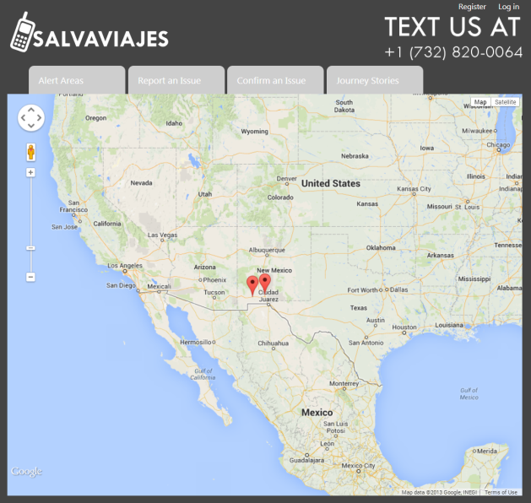 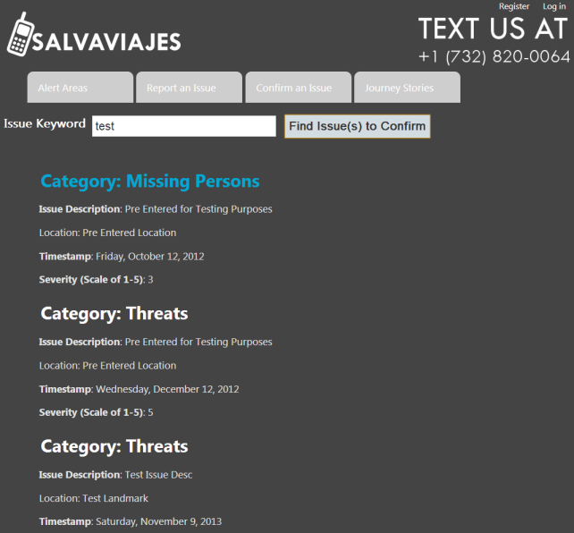

Contacts of Confirmed Humanitarian Group

* Can register and create login accounts
* Can view current issue details
* Can view verified help group’s info
* Can view publish journey stories

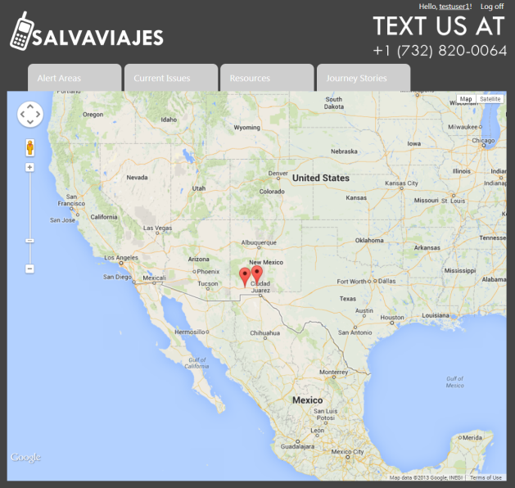 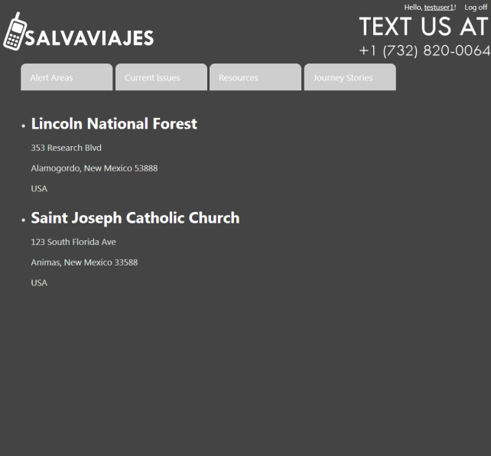

# Potentials

**Web Site Potentials**

* Enabling web site account creation workflow
  + Populate real humanitarian group info
  + Validate official contacts in each humanitarian group
  + Enabling web site user accounts being created for the validated users
* Enabling journey data and documentary processing workflow
  + Enable journey path data entry
  + Enable journey (or path) documentary and digital file attachments
  + Include human curating the journey data
  + Publish journey stories
* Enabling data curation workflow
  + Certain data entries are marked as needing curation initially
  + A wizard connects pieces of data that needs to be human curated
  + Journey story will be published once major data is curated
* Enabling journey story composing function
  + Using predefine journey story templates or
  + Using user defined journey story templates
* Polish the web site look and feel with professional designer’s touch

*The data schema has been designed with all these potential features in mind